Organisation Mondiale pour l'Education Prescolaire
World Organization for Early Childhood Education
Organización Mundial para la Educación Preescolar

Ο.Μ.Ε.Ρ.
Vice President for Europe
Department of Educational Science
and Early Childhood Education
University of Patras
265 04 RION – Greece

E-mail: nekstel@upatras.gr 13th December 2013

To European National Committees
Current issues
- Website
I am happy to announce you that the European Regional website is ready. Please, visit the address www.euromep.org. Notice that this page is being developed on voluntary basis. Please, send me photos, announcements and other materials to add. In “News” and “Vice President “sections you can see current news and activities.
- Next Conferences and Regional Meetings
In 2014 there will be not a Regional Conference since the World Assembly and Conference is in our region. Since the submission of papers to 66th OMEP World Assembly and International Conference is open till 17 of January 2014, I kindly ask you to visit the website www.omepireland.ie and spread the information in your country. Please, inform not only our members but, also, people from academia, persons and organizations working on Early Childhood Education and stuff members.
Recently the World President met in Moscow the Russian President and she told her about our enthusiasm on European Regional Conference and Meeting, which is going to be held in Russia in spring 2015.
- Support a training program in Kenya
Based on our decision for establishing a strong partnership with a less prosperous country in Africa or elsewhere I would like to inform you that Professor John Siraj-Blatchford is going to organize a seminar in Kenya. He needs our support. I am attaching his letter. Please, discuss this issue with the members of your National Committee and support his efforts. I do know that in our countries we have a lot of problems and we have to give priority to them. On the other hand, we shouldn’t forget that we are still richer than other regions and solidarity should be one of our priorities. Please, do not ignore this call.

- Annual Reports
As you know “Annual Reports” are very important for our presentation in public. In order to make the submission easier this year the Annual Reports will be submitted electronically. We will receive precise information later, but, please, start collecting the data concerning your committee.
- On 10 and 11 of December 2013 I participated in a Networking Conference organized by Social Platform of European Union in Athens. I had the chance to present our Organization and comment upon the situation of ECEC in my country, which is hit severely by the current multifaceted crisis. Since in our last regional meeting in Shanghai quality was one of the topics, I forward you my presentation.

- The end of the year is approaching. I have to thank once more from the deep ends of my heart the World President, Ingrid Pramling – Samuelsson, for all her efforts to bring our Organization in the current status for which are really proud. She leaves the chair, but not OMEP. She will be always with us. The baton passes to Maggie Koong and I send her my warmest wishes for a fruitful presidency.

Lastly, I am sending you, the members of your committee, the friends of our Organization, the children and their families my warmest wishes for Merry Christmas and a Happy New Year.

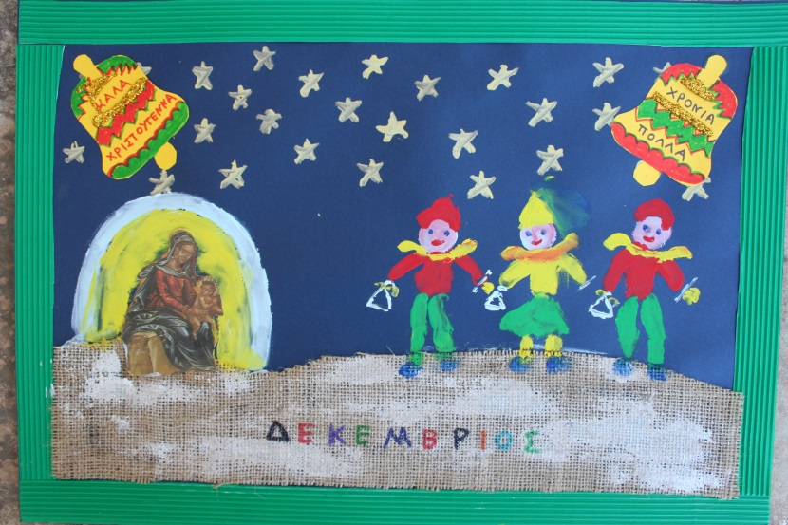

With my warmest regards and looking forward to hearing your news
Nektarios Stellakis
Vice President of OMEP for Europe

LETTER FROM PROFESSOR JOHN SIRAJ_BLATCHFORD
I’m writing to wish you a happy Christmas and to tell you about my New Year resolution.
I'm going to walk for OMEP in 2014 to support the OMEP UK-Kenya Partnership and to support preschool teachers in Kenya who suffer the same poverty as many of the children they work with. Preschool teachers in Kenya have to pay for their own training, yet a typical pre-primary teacher salary is between £16 - £30 UK a month (2,000 – 4,000 Ks) - and to put this in perspective a chicken in Kenya costs about 600 Ks…
OMEP is trying to create partnerships between preschools, preschool teachers, and preschool teachers in training in the UK and in Kenya. If it works, then we will have a model for many more OMEP international collaborations. You can help by indicating your support, and encouraging more support for this project – to do that all you need to do is simply ‘like’ the project facebook page: https://www.facebook.com/omep.kenya.page
For more information see: the OMEP Kenya website: http://www.omep.or.ke/
If you (or anyone you know) would like to support the project more directly see:
My Donate: https://t.co/ZrSstP0aW6
Photostream: http://t.co/XqHyb9SApX
For more information see: the OMEP Kenya website: http://www.omep.or.ke/
If you would like to support the project more directly see:
My Donate: https://t.co/ZrSstP0aW6
Photostream: http://t.co/XqHyb9SApX
Professor John Siraj-Blatchford
http://www.327matters.org

